**Department of Computer Engineering**

**University of Peradeniya CO226-Database Systems**

Lab Sheet Number : 06

Topic: Writing SQL Queries – Part II

Reg. No: E/18/397

**Task**

1) A) select * from movie where director in (select name from reviewer);

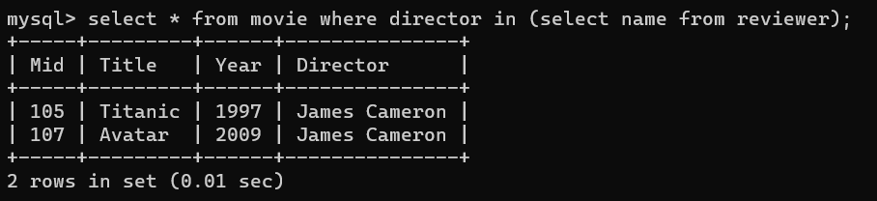

B) select * from movie where director not in (select name from reviewer);

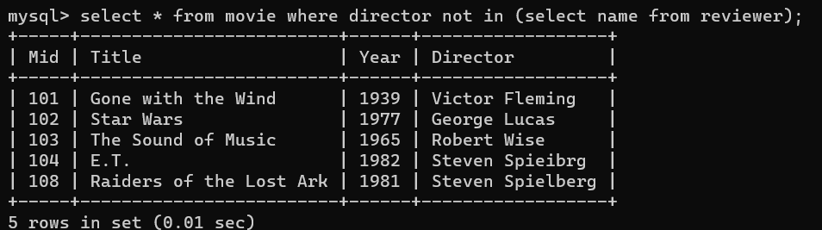

2) A) select * from rating where rid in (select rid from reviewer where name= "Sarah Martinez");

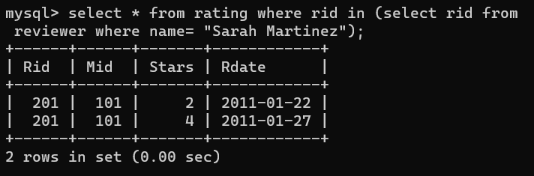

B) select * from rating where rid not in (select rid from reviewer where name= "Sarah Martinez");

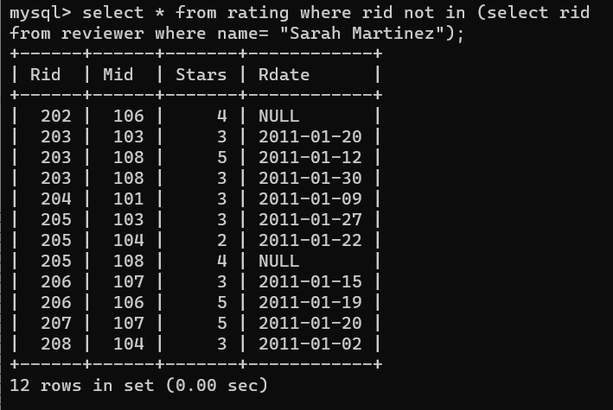

3) A) select mid from rating where stars < ANY (select stars from rating where mid=103);

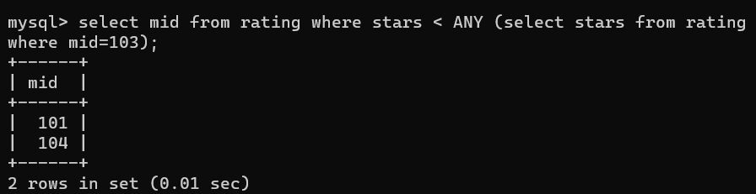

B) select mid from rating where stars <= ANY (select stars from rating where mid=103);

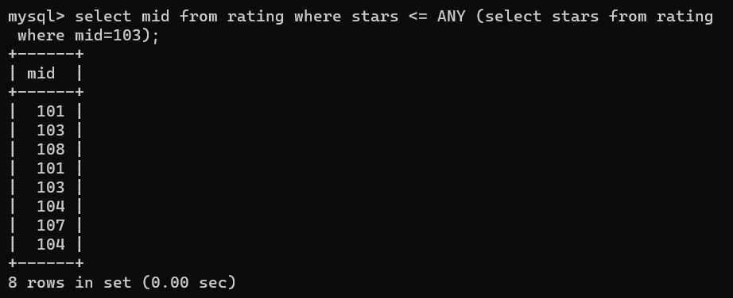

C) select mid from rating where stars = ANY (select stars from rating where mid=103);

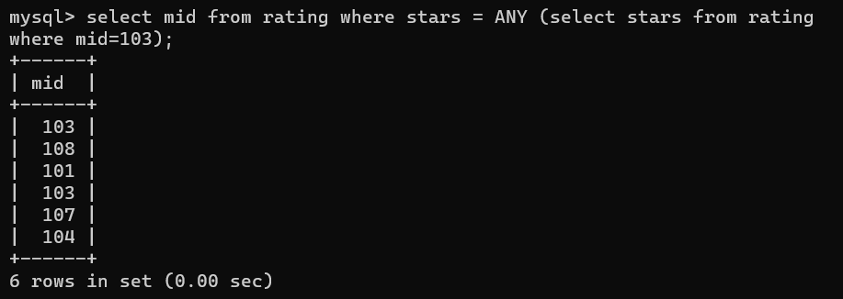

D) select mid from rating where stars > ANY (select stars from rating where mid=103);

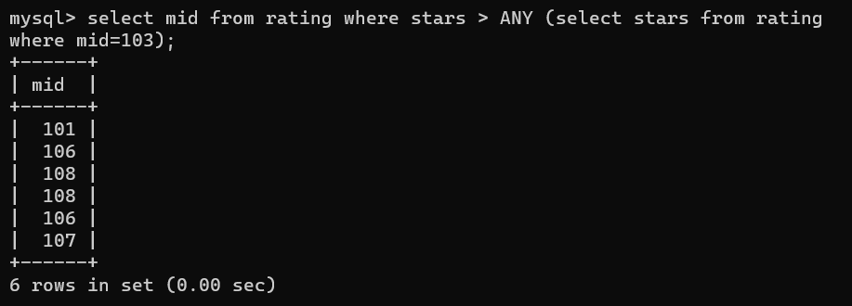

E) select mid from rating where stars >= ANY (select stars from rating where mid=103);

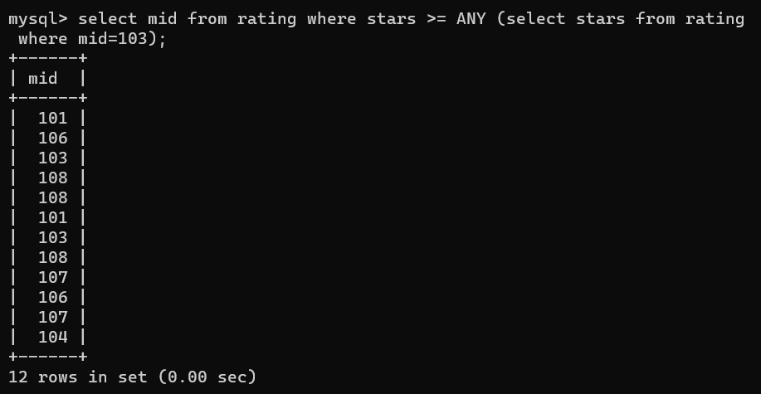

F) select mid from rating where stars <> ANY (select stars from rating where mid=103);

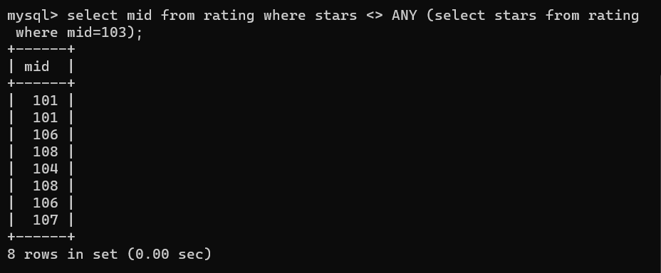

4) select rid from rating where mid in (select mid from rating where rdate = "2011-01-12") AND stars IN (select stars from rating where rdate="2011-01-12");

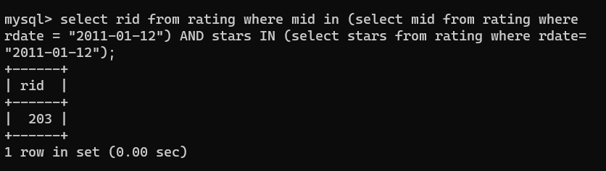

5) A) select distinct year from movie, rating where movie.mid = rating.mid AND (rating.stars=4 or rating.stars=5) ORDER BY year ASC;

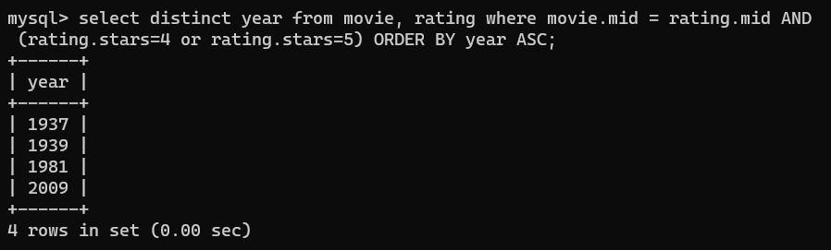

B) select year from movie where mid in (select mid from rating where stars=4 or stars=5) order by year asc;

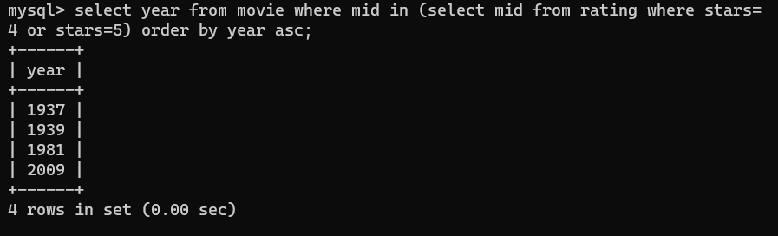

6) A) select title from movie where mid not in (select mid from rating);

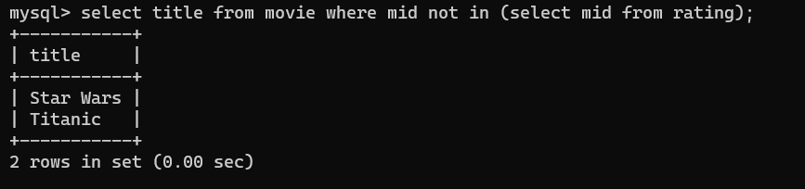

B) select title from movie a where mid <> all (select mid from rating b where a.mid = b.mid);

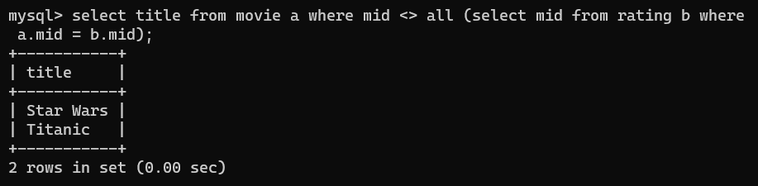

7) A) select name from reviewer, rating where rating.rid = reviewer.rid AND rdate is NULL;

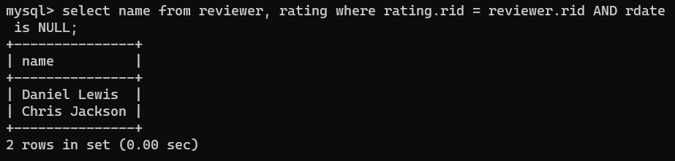

B) select name from reviewer where rid in (select rid from rating where rdate is NULL);

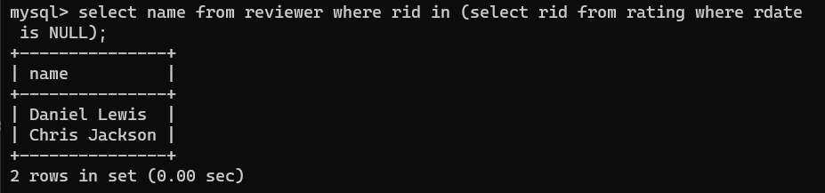

C) select name from reviewer where rid = ANY(select rid from rating where rdate is NULL and reviewer.rid = rating.rid);

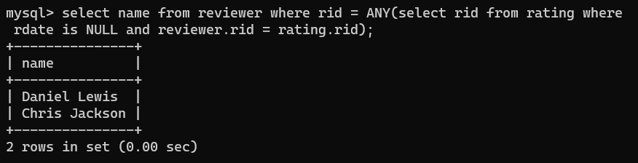

8) A) select title , MAX(stars) from movie, rating where movie.mid = rating.mid group by movie.mid order by movie.title asc;

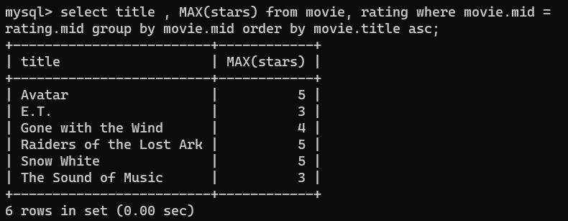

B) select title , MIN(stars) from movie, rating where movie.mid = rating.mid group by movie.mid order by movie.title asc;

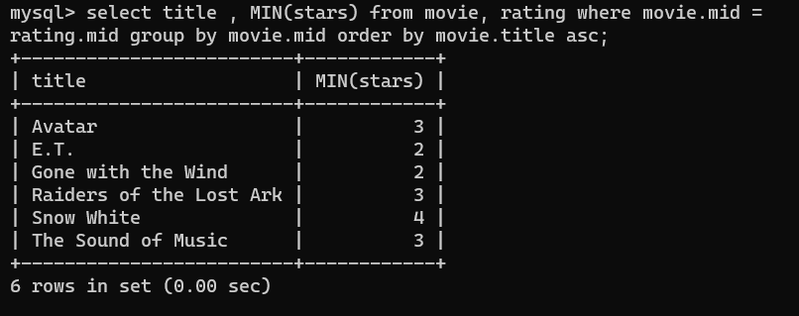

C) select title , AVG(stars) from movie, rating where movie.mid = rating.mid group by movie.mid order by movie.title asc;

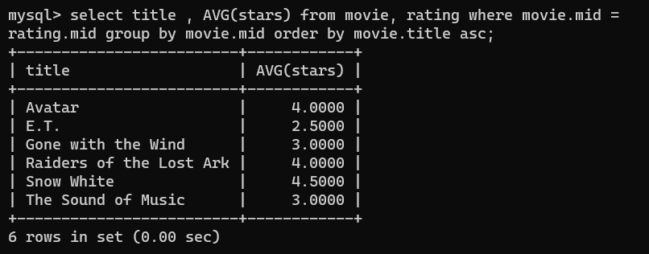

D) select title , SUM(stars) from movie, rating where movie.mid = rating.mid group by movie.mid order by movie.title asc;

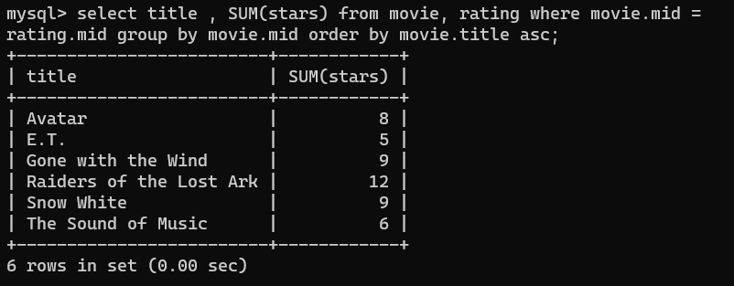

E) select title , COUNT(*) from movie, rating where movie.mid = rating.mid group by movie.mid order by movie.title asc;

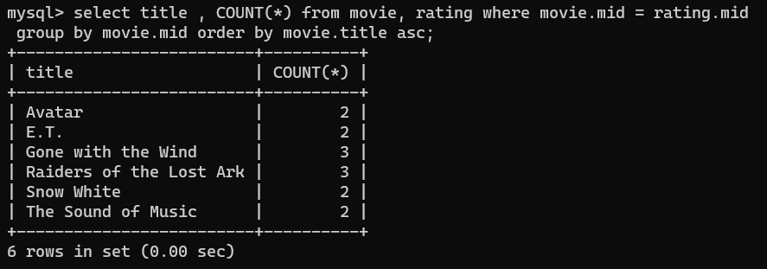

9) A) select name from reviewer , rating where rating.rid = reviewer.rid GROUP by rating.rid HAVING COUNT(*) >= 3;

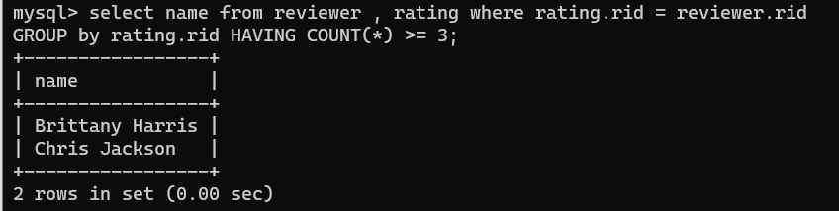

B) select name from reviewer where rid in (select rid from rating group by rating.rid HAVING COUNT(*) >=3);

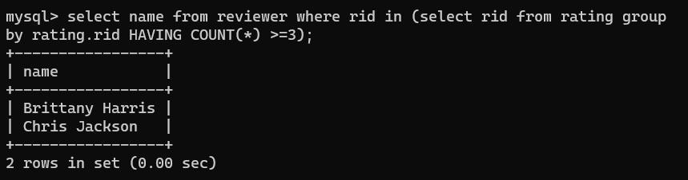

C) select name from reviewer where 3 <= ANY (select count(*) from rating where reviewer.rid = rating.rid);

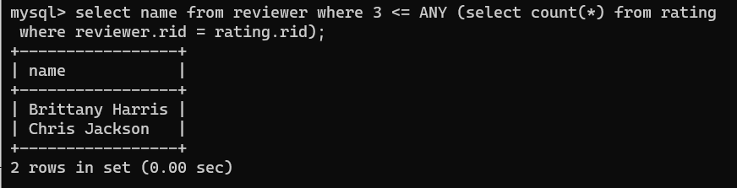

10) select title, avg(stars) from movie, rating where movie.mid = rating.mid GROUP by movie.mid ORDER by avg(stars) desc, title asc;

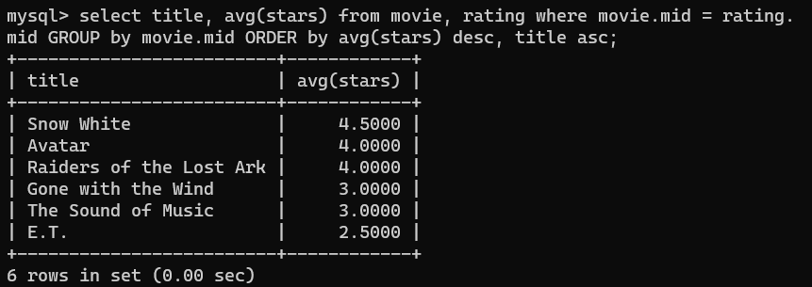

11) delete from rating where mid in (select mid from movie where year<1970 or year>2000);

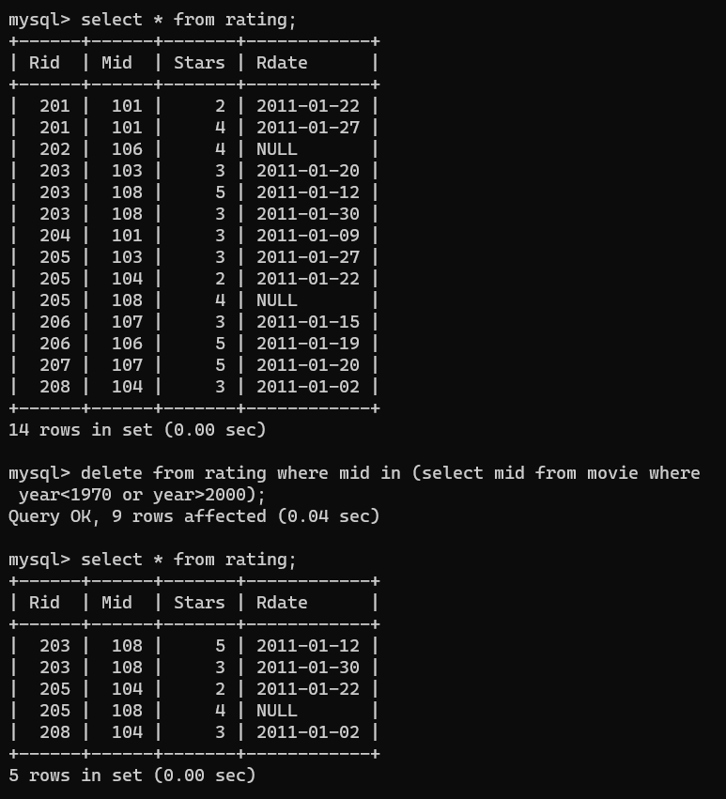

12) delete from rating where rdate is null;

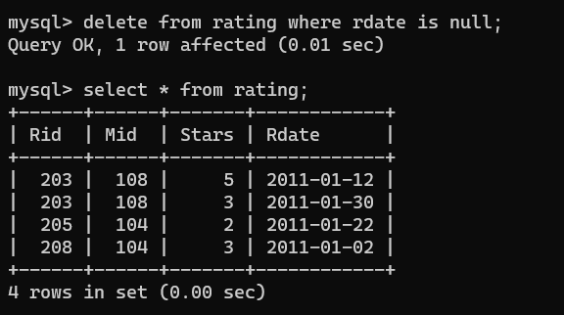

13) insert into rating select rid, mid , 5 , null from reviewer, movie where name = "James Cameron";



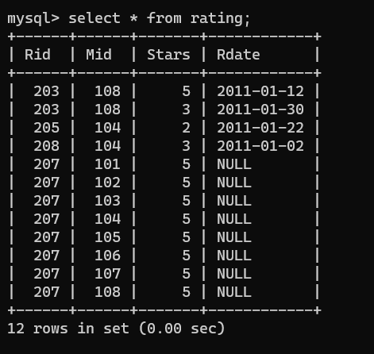

14) update movie set year = year + 25 where mid in (select rating.mid from rating group by rating.mid having avg(stars)>=4);

